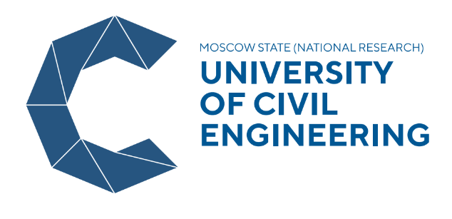

National Research Moscow State University of Civil Engineering

Microbiology in Urban Design

BioCity
18 August – 31 August 2019 (two-week course)
Moscow

Application form

Photo

Surname
Given name
Male/female
Date of Birth
Place of Birth
Country of citizenship
Name of University (full)
Degree programme (Bachelors, Masters, PhD)
Field of study
Home address
Phone
E-mail address
Level of Russian language | - Full Beginner  - Elementary level  - Intermediate level

Please attach a copy of your passport for visa Invitation

